Making Insulating Dough

Subject:  Related Subjects: | Grade Level(s):  Length of Lesson: | Type: Inquiry / Design / Project  Keywords:

Lesson Overview
Use this section to describe at a high level what the lesson is. Should be no more than 3-4 lines.

Lesson Focus
What is the central question or phenomenon being investigated? What problem are they trying to solve?

Lesson Objective(s) | By the end of this lesson, students will…  - Learn the concepts of attraction, repulsion, friction, polarity, and charge.

Lesson Timing

5 minutes | Introduce the Lesson
30 minutes | ...

Materials | 1 1/2 cup Flour  1/2 cup Sugar  3 Tbsp. Vegetable Oil  1/2 cup Deionized (or Distilled) Water  (Regular tap water can be used, but the resistance of the dough will be lower.)
Instructor Prep | - Step 1
Related Resources | - List related lessons/ppts etc available from USC or outside, trusted orgs

Lesson Plan

Introduction
Introduce students to the learning goals and make connections to past and present learning experiences. Stimulate interest and prompt students to identify their own questions about the topic. This can link the lesson to real world examples, introduce associated STEM careers, and assess their prior knowledge on the topic.

- Step 1

Procedure

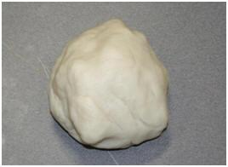
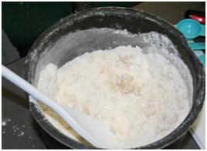
1. Mix solid ingredients and oil in a pot or large bowl, setting aside ½ cup flour to be used later.

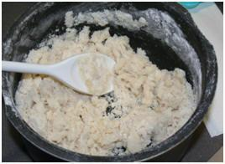2. Mix with this mixture a small amount of deionized water (about 1 Tbsp.) and stir.
3. Repeat this step until a majority water is absorbed by the mixture.

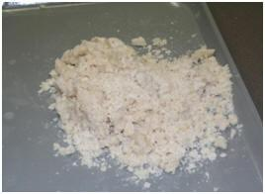4. Once your mixture is at this consistency, knead the mixture into one “lump”.

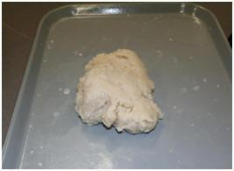5. Knead more water into the dough until it has a sticky, dough-like texture.

6. Now, knead in flour to the dough, until a desired texture is reached.
7. Store in an airtight container or plastic bag. While in the bag, water from the dough will create condensation. This is normal. Just knead the dough after removing it from the bag, and it will be as good as new. If stored properly, the dough should keep for several weeks.

Wrap-up
End the lesson with some final discussions about what students designed/discovered. Connect their activity back to the focus question/problem, real world examples, and STEM careers.

Also include notes about any special cleanup considerations

Lesson Background for Teachers

Suggested Real-World STEM Connections
- List possible related Role Models in STEM (with details and links to more reading). Give suggestions for examples of scientists/engineers who are from underrepresented groups in STEM in related careers.
- List related real-world engineering problems and examples

Lesson Variations and Options
Include descriptions of alternative methods or ways to present things.

Explanation
Describe the background concepts and explanations behind the lesson. This can be more in depth than a teacher/instructor would actually share with students.

Key Concepts and Vocabulary
- Word 1: Grade Appropriate Definition
- Word 2: Grade Appropriate Definition

Safety Notes
- Safety instruction

